Lab 1: Problem Discovery and Need Identification
24beis133

Problem statement

Families struggle to manage household waste effectively.

Step 1: Observation:

Observation Log
- Many families mix wet waste, dry waste, and hazardous waste in a single bin.
- Lack of awareness about waste segregation rules.
- Confusion about what items are recyclable and non-recyclable.
- Overflowing bins due to irregular waste collection schedules.
- Bad odor and unhygienic conditions in kitchens and common waste storage areas.
- Plastic waste accumulation due to excessive packaging.
- Lack of space in homes to keep multiple bins.
Record :
- Irregular municipal waste collection
- Limited space in apartments
- Lack of clear labeling on bins
- Absence of awareness campaigns

Step 2: User Identification:

Stakeholder List
User Group | Role | Expectations
Households / Family Members | Generate and manage daily waste | Easy disposal, cleanliness, hygiene
Waste Collectors / Sanitation Workers | Collect segregated waste | Proper segregation, timely collection
Municipal Authorities | Manage waste systems and recycling | Reduced landfill load, proper waste processing

Step 3: Interviews :

Sample Interview Questions
- How often does your household dispose of waste?
- Do you separate waste at home (wet, dry, plastic, etc.)?
- If you do not separate waste, what is the main reason?
- Do you have access to proper waste collection services in your area?
- How easy is it for your family to manage household waste?

Key Insights from Interviews
- Most families do not consistently segregate waste.
- Lack of knowledge about recyclable items.
- Space constraints prevent keeping multiple bins.
- Busy schedules reduce attention to waste management.
- Limited guidance from local authorities.
List of Responses :
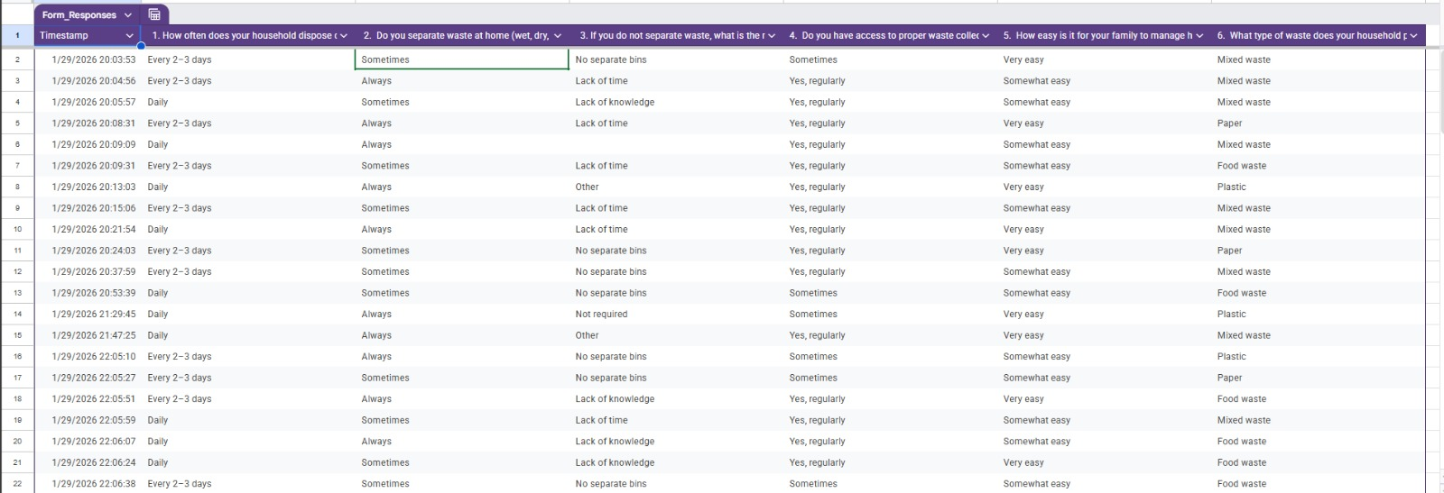
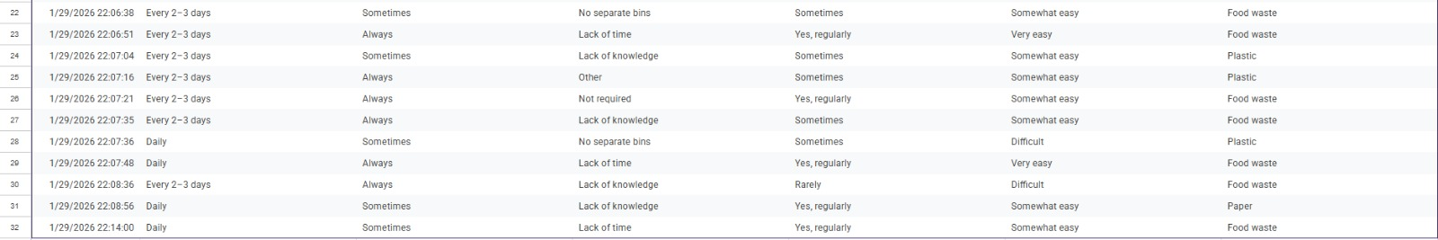

Step 4: Pain-Point Analysis
Category | Identified Pain Points
Functional | Difficulty segregating waste, lack of storage space
Emotional | Frustration, guilt about environmental harm
Systemic | Poor collection schedules, lack of awareness programs
Critical Pain Point:
Lack of awareness and convenient systems for effective household waste segregation and disposal.

Step 5: Root Cause Identification

5-Why Analysis
Why do families struggle to manage household waste?
→ They do not segregate waste properly.
Why is waste not segregated?
→ They lack knowledge and find the process inconvenient.
Why do they lack knowledge?
→ Limited awareness campaigns and education.
Why are awareness campaigns limited?
→ Insufficient focus from municipal bodies and authorities.
Why is focus insufficient?
→ Waste management is not treated as a priority public behavior issue.

Root Causes Identified
- Lack of public awareness programs
- Inadequate waste management infrastructure
- Poor communication from municipal authorities
- Absence of user-friendly segregation systems

Step 6: Wicked Problem Understanding
This problem is classified as a Wicked Problem because:
- Multiple stakeholders are involved: families, waste collectors, municipalities, recyclers.
- Behavioral change is difficult and slow.
- Cultural habits influence waste disposal practices.
- Infrastructure limitations vary by location.
- No single solution can work for all households.
Thus, household waste management requires combined efforts of education, infrastructure, policy enforcement, and behavioral change.

Step 7: Reflection
Through this study, I realized that household waste management is not just a technical problem but a behavioral and social challenge. Initially, I assumed families were careless, but interviews showed that lack of awareness, space constraints, and poor collection systems are major barriers. User perspectives helped me understand real-life difficulties. Jumping directly to solutions without understanding root causes can lead to ineffective outcomes. This lab helped me develop observation skills, empathy, analytical thinking, and problem-identification ability.

